Statistics Research Project

For our research project we wanted to see if there was a correlation between a person’s weight and their blood pressure. We decided to use BMI (body mass index) instead of actual weight, because it is a better indicator of a person’s true fat percentage. We also only used the systolic blood pressure as a unit of measurement.
We collected data from 55 randomly selected hospital charts of people between the ages of 40-70. We then recorded the systolic blood pressure along with their height and weight. We calibrated their BMI by dividing the person’s weight in kilograms by the square of their height in meters.
On the next page you will see our mean, standard deviation range and mode along with other data that we pulled together in excel. For a new excel user, this was quite an interesting process. It was fun to see how quickly the program could pull this information out of our data.

systolic blood pressure
Mean | 129.0364
Standard Error | 2.386404
Median | 128
Mode | 146
Standard Deviation | 17.69805
Sample Variance | 313.2209
Kurtosis | -0.08214
Skewness | 0.467793
Range | 82
Minimum | 95
Maximum | 177
Sum | 7097
Count | 55
Largest(1) | 177
Smallest(1) | 95
Confidence Level(95.0%) | 4.784452
BMI
Mean | 28.628
Standard Error | 0.96975
Median | 27.7
Mode | 22.89
Standard Deviation | 7.191858
Sample Variance | 51.72282
Kurtosis | 0.827151
Skewness | 0.841357
Range | 32.79
Minimum | 17.09
Maximum | 49.88
Sum | 1574.54
Count | 55
Largest(1) | 49.88
Smallest(1) | 17.09
Confidence Level(95.0%) | 1.944232

We then created 3 histograms the first shows the range we recorded in BMI. The second one shows the recorded systolic blood pressures. In the third we merged them together so we could see if it was going to look like there was a correlation. We were sadly disappointed by our results.
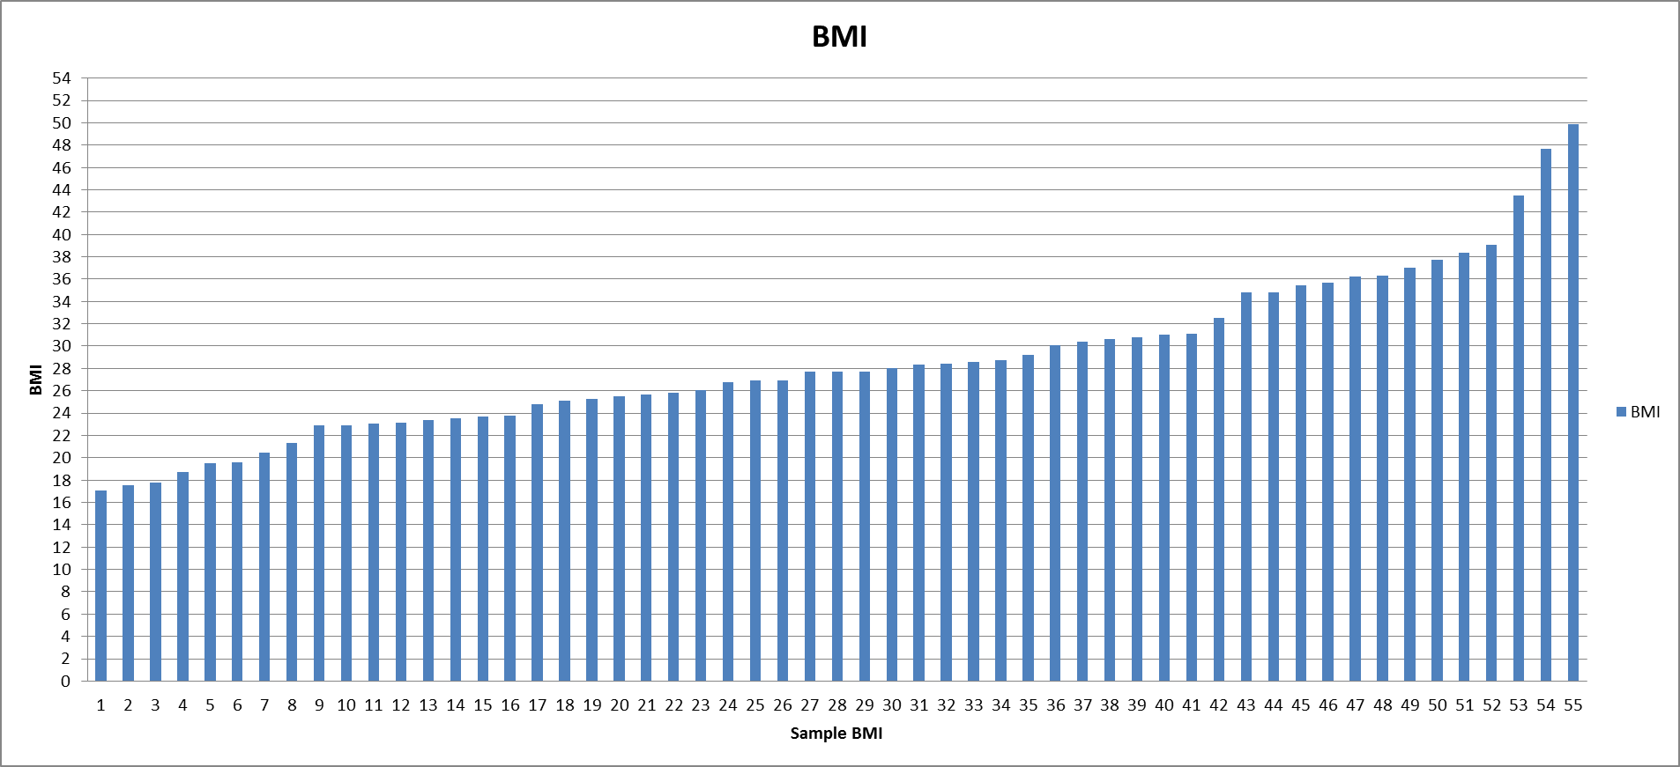
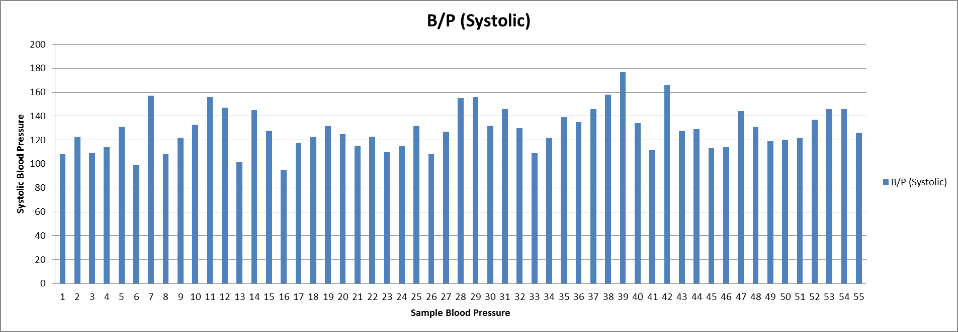
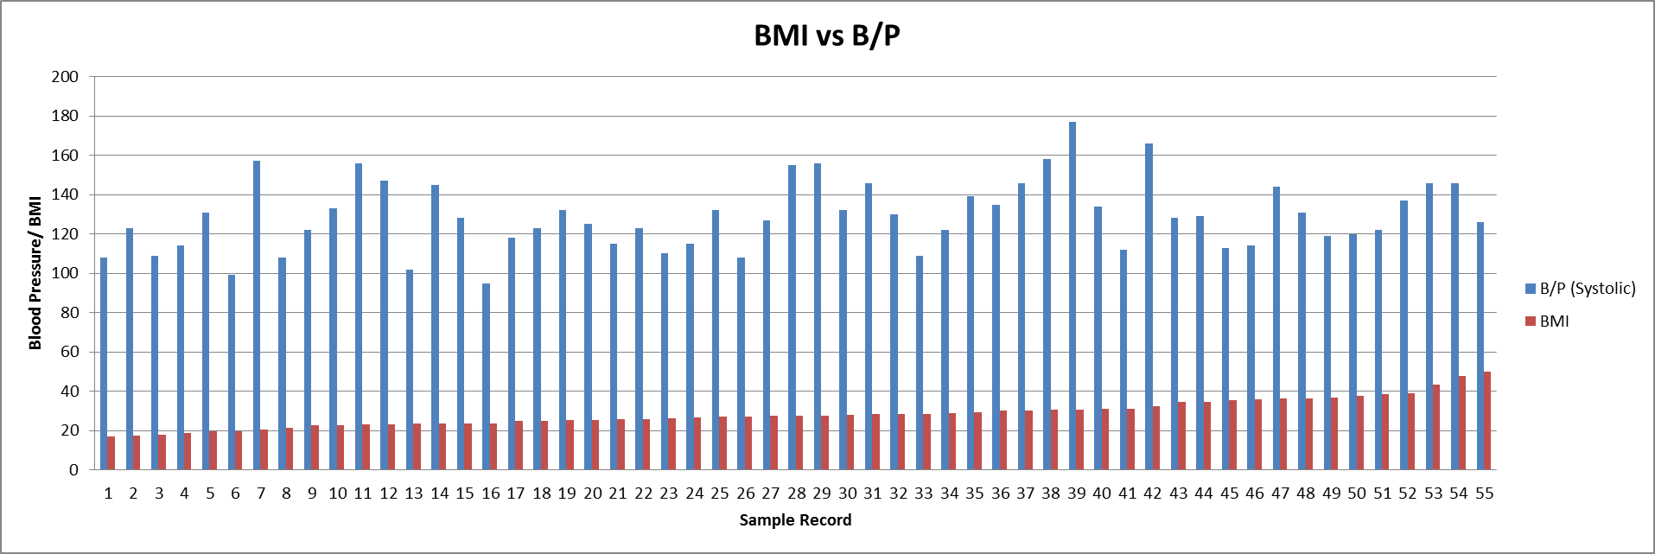
We had expected to see the blood pressure rise along with the increased BMI. However, it pretty clearly shows that the blood pressure stays random as the BMI increases. Our scatter plot also shows no correlation.

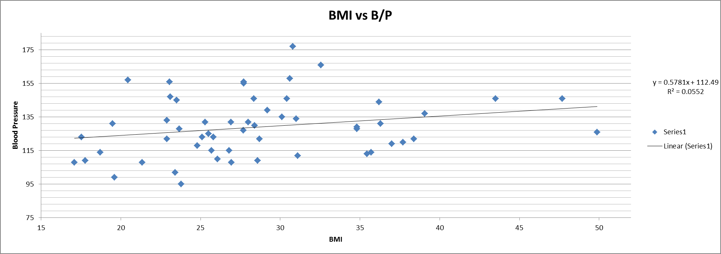

On this graph, it shows our linear regression line and our correlation coefficient was figured to be 0.234932. This number verifies that there is really no correlation between the two variables in our study.

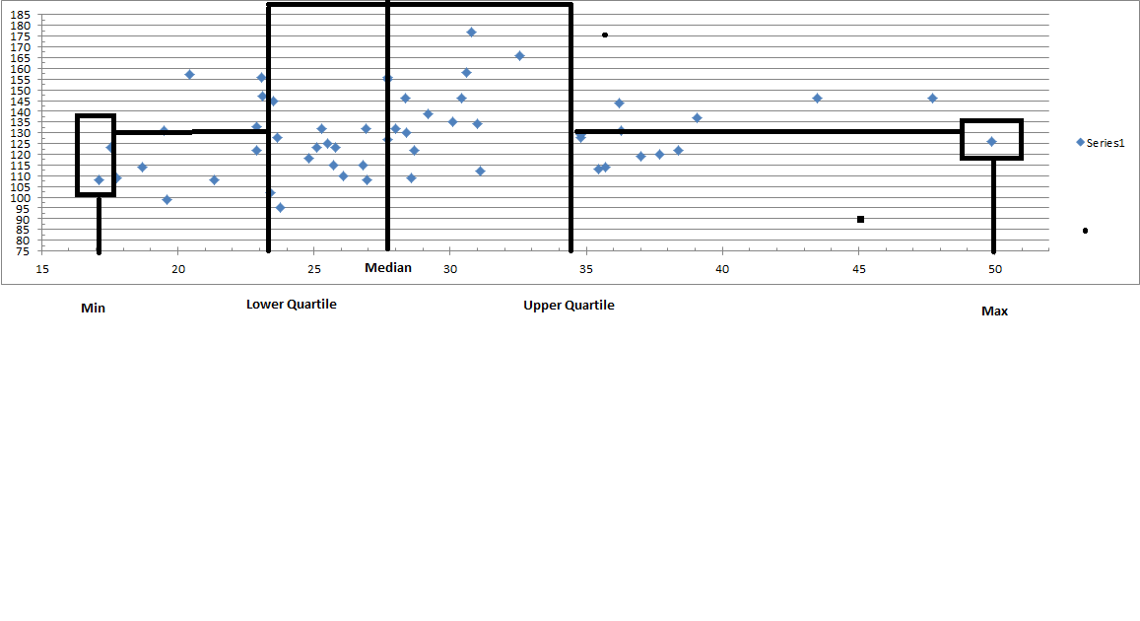
This box plot was hard to do, but does have our five-number summary
B/P BMI
Min 95 17.09
Q1 115 23.585
Median 128 27.7
Q3 141.5 31.83
Max 177 49.88
Range 82 32.79
Mode 146 22.89

Our study was flawed. We were unable to weed out confounding variables (such as whether or not the patients were already on B/P medications, gender, overall health and age range) due to time and resources available to us.
The results of our study showed us as a group that getting a true Statistical result is more difficult than we initially expected. It is much more time consuming and labour intensive to collect the data than we could have ever imagined without this class. This course has given us new appreciation for studies that we will see in the future whether in newspapers or magazines. We now know how to read the information presented, how to pull out the important information, and have an idea of whether it is biased or skewed.

